N-BOX-J6

◆ with Baytrail-D/I/M serial Processor；
◆ J1900\J1800\E3845；
◆ DDR3 SODIMM 204 Socket Max support 8G；
◆ 6*Intel I211ATOr Intel I210 Gigabit LAN (optional)；
◆ Onboard 32/64/128G EMMC chip (optional);
◆ 1*RJ45 interface RS232 or RS485 (choose one)
◆ Single input DC power supply, DC12-19V power supply;
◆ size: 134*126*40.6mm

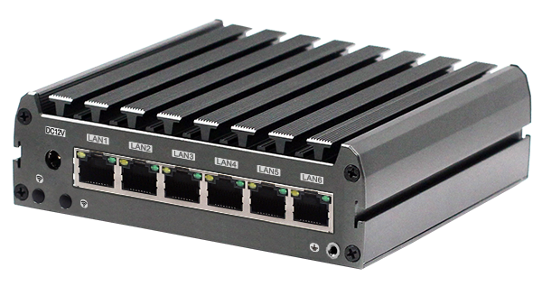

Main features
CPU | CPU | With Baytrail-D/I/M serial Processor
CPU | CPU package | BGA
CPU | Chipset | Baytrail-D/I/M serial Processor
CPU | BIOS | EFI BIOS
Memory | Technology Architecture | Single channel DDR3L 1066/1333MHz
Memory | capacity | Max support 8GB DDR3L memory
Memory | Socket | DDR3 SODIMM 204 Socket
Video | Graphics controller | Intel HD Graphics
Video | HDMI | HDMImax support resolution 1920x1080
I/O backpanel | Ports | 1*HDMI  1*USB3.0  1*USB2.0  6*LAN  1*Quick start button with indicator  1*Reset button  1*DC 1*Power indicator  1*Hard disk indicator
Internet | controller | 6*Intel I211ATOr Intel I210 Gigabit LAN (optional)
Input or output interface | USB | 1*USB2.0 1*USB3.0 max support+5V/1A
Input or output interface | Com | 1*RJ45 Port RS232 or RS485(optional)
Expansion bus | Mini-PCle | 1*Mini-PCIe, support PCIE and USB protocol signal equipment
storage | SATA | 1*standard SATA3 Port, max transmission rate 6Gb/s
storage | M-SATA | 1*Mini-PCIe M-SATA Scoket, support SANDISK protocol，max transmission rate 6gb/s
storage | EMMC | Support 32/64/128G (optional)
power supply | Power type | Single input DC power supply, DC12-19V, +/- 5%
working environment | Operating temperature | -20℃ ~ +60℃
working environment | storage temperature | -40℃ ~ +85℃
working environment | Working humidity | 0% ~ 90% relative humidity, no condensation
working environment | Storage humidity | 0% ~ 90% relative humidity, no condensation
System support |  | Windows7 Windows10 Linux Android
Measurement | size | 134*126*40.6 mm
Measurement | weight | 0.5KG
Certifications |  | CE,ROHS,FCC

N-BOX-J6

尺寸 单位：mm
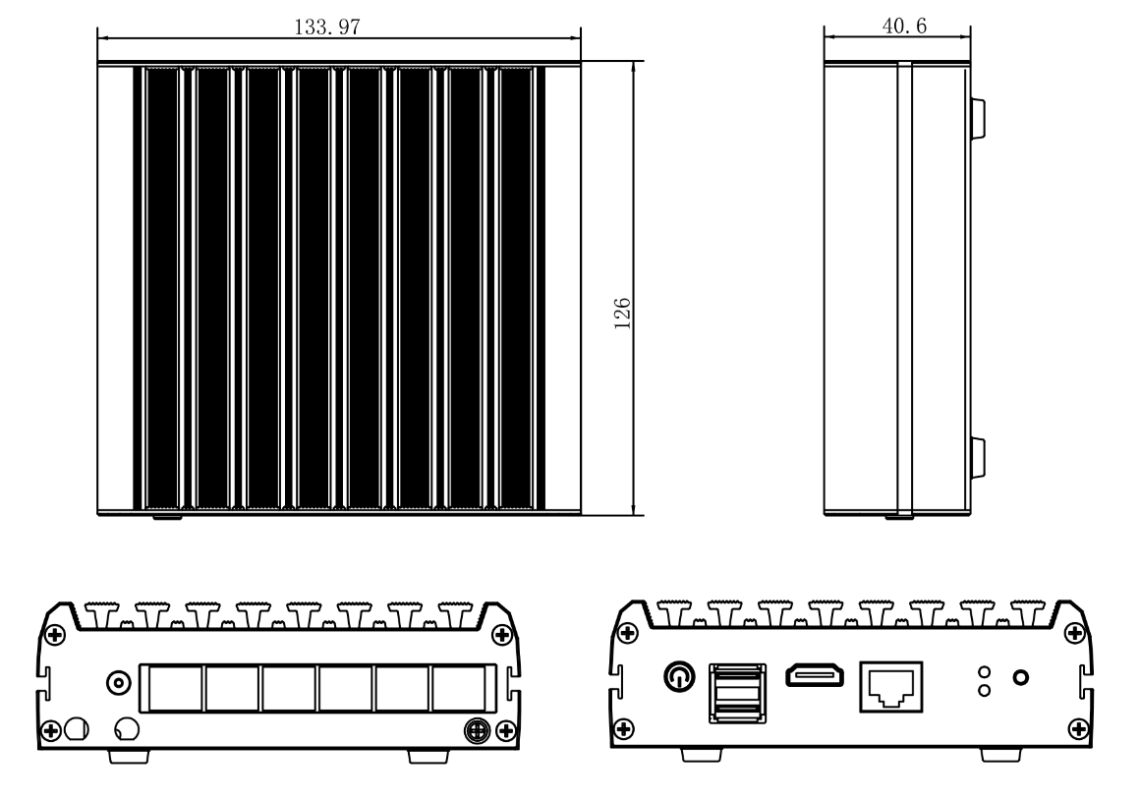

Order information
Module | description | CPU optional
N-BOX-J6 | Integrated Baytrail-D/I/M CPU  DDR3 SODIMM 204 Socket Max support 8gb ram  Integrated 32G/64/128G EMMC chipset (Optional） | J1900(quad core）  2.0Ghz up to2.4Ghz  E3845(quad core）  1.91Ghz  J1800（dual core ）  1.6Ghz up to2.0Ghz

